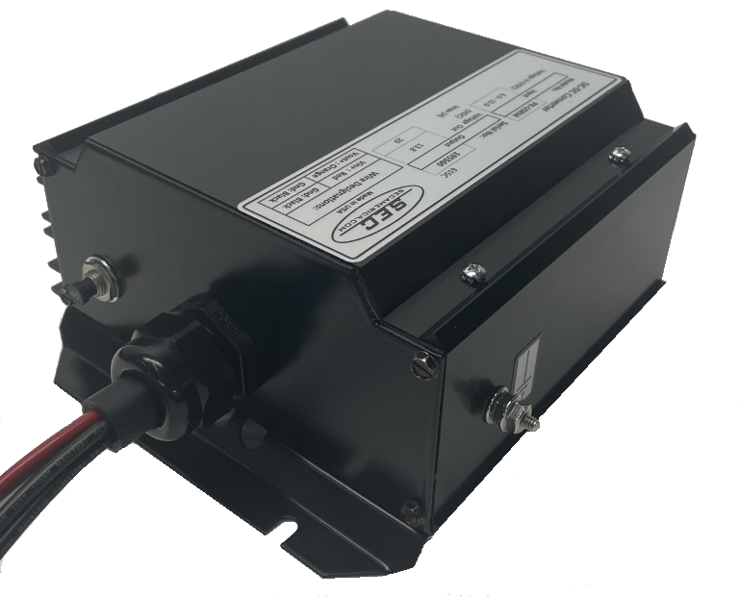

Model 615C
DC-DC Converter
Owner’s Manual

February 16, 2022

TABLE OF CONTENTS

page

I Introduction 1

II Installation 1
2.1 Mounting 1
2.2 Connections 1
2.3 Methods of Converter Activation 2
2.4 Power Limiting & Overload Protection 2

III Internal Adjustments 3
3.1 Turn-On Sequence 3
3.2 Input Current Limit 3
3.3 Output Current Limit 3

IV Warranty 4

V Mechanical Drawing of Base Plate 5

I Introduction

After removing Model 615C from its packaging and ensuring that it has suffered no damage in shipment, it is important to read this manual and follow its instructions to ensure proper connection and mounting.

Model 615C is a high-power DC-DC converter with an active input range capability of 5VDC-15VDC. Its maximum output current is 20A at 13.8VDC. Its main application is to regulate the input voltage of communications equipment regardless of vehicle voltage fluctuations. Model 615C is designed for mounting in vehicles of all types and is capable of enduring harsh vibration and shock conditions

II Installation

2.1 Mounting
Model 615C has an overall length of 8.8 inches with mounting flanges included in this dimension. Hole mounting centers are 7.3 x 3.75 (inches).

2.2 Connections

Figure 1 shows the connection panel view of the 615C

Wire Designations:
Vin+ : Red | Gnd: Black
Vout+ : Orange | Gnd: Black

Figure #1

Page 1

Prior to Main Input Power Connections:

Make connections A through D prior to hook up to the vehicular power source as shown in Figure #2. This ensures that there is no sparking from the source of power and allows a reprieve in case there is a hook up error. (User should carefully review connections as such an error would have to be detected prior to energizing the unit).

Wire Designations:
Vin+ : Red | Gnd: Black
Vout+ : Orange | Gnd: Black

- Connect input +(6-15)V line to Red Wire of the Wire Connection Bushing.
- Connect input ground to either Black Wire of the Wire Connection Bushing
- Connect output ground to either Black Wire of the Wire Connection Bushing
- Connect output +13.8V line to the Orange Wire of the Wire Connection Bushing
Note: The two ground wires are interchangeable.

Prior to energizing, installer should:
- Ensure that hook up in steps A through D is correct.
- Select the suitable method of converter activation.

2.3 Methods of Converter Activation

  - Ensure that the circuit breaker button is pushed in, with the white portion of its shaft hidden. The 615C is so configured when shipped from the factory. This configuration allows for converter activation by turning the DC source power ON.
  - Alternately, with the DC source remaining connected, the converter can be activated by using the circuit breaker as a switch.

2.4 Power Limiting & Overload Protection

The 615C begins to electronically limit power once 20A current draw is exceeded.
In the event that the converter is misused e.g. its input is connected in reverse polarity, the circuit breaker on the panel provides secondary protection. IT IS ADVISABLE TO TRY TO AVOID REVERSE POLARITY AS IT MAY RESULT IN PERMANENT DAMAGE TO THE UNIT.

Page 2
III Internal Adjustments
Varying the output voltage adjustment of the Model 615C requires entry into the unit and should be made accessible only by technical personnel. It is not user adjustable.

3.1) Voltage Turn-On Sequence

The converter requires an input of 9V minimum to initially become active. Once the circuit is active it will have a full input regulation range down to a minimum of 8V and a maximum of 15V. In extreme conditions as experienced during engine cranking the converter will maintain an output voltage of 13.8V with input as low as 8V while supporting a load of 17A.

3.2) Effect of Input Current Limits on Continuous Output Current

The input circuit breaker limits the input current to 40A. This in turn limits how much continuous output load current is available at very low input voltages. Table 1 shows this correlation.

Input (VDC) | Cont. Output (A) | Output (VDC)
6 | 13.04 | 13.8
6.5 | 14.13 | 13.8
7 | 15.22 | 13.8
7.5 | 16.30 | 13.8
8 | 17.39 | 13.8
8.5 | 18.48 | 13.8
9 | 19.57 | 13.8
9.5 | 20.00 | 13.8
>10 | 20.00 | 13.8
 | TABLE 1

3.3) Output Current Limit at Input Voltage Greater than 10V

Notwithstanding the decrease in input current demand at higher voltages, the converter limits output current to a maximum of 20A

These ratings in 3.1 and 3.2 apply throughout a temperature range from -40C to +40C with derating of 20% for every 10C above 40C up to a maximum of 60C.

Page 3

IV Warranty and Repair

Should your investigations indicate that your new Model 615C is defective or damaged and the unit is still under warranty then contact SEC America Corp. at 802-865-8388 and obtain return merchandise authorization for credit or exchange.

If the warranty period has expired or if the warranty has been violated due to operator error or misuse, call:
SEC America Corp., Repair Department, at 802-865-8388 or fax SEC America Corp. at 802-865-8389 to receive authorization for shipment back to factory for a survey and possible repair.

Warranty

The Model 615C has a 2-year warranty covering parts and labor. The warranty is found below:

Page 4

V Base Plate Mechanical Drawing

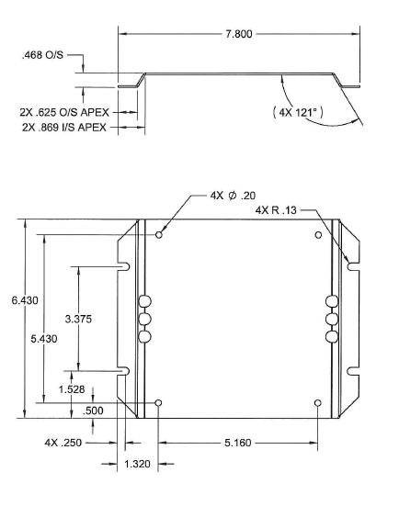

Page 5

Model 615C DC-DC Converter
Owner’s Manual

